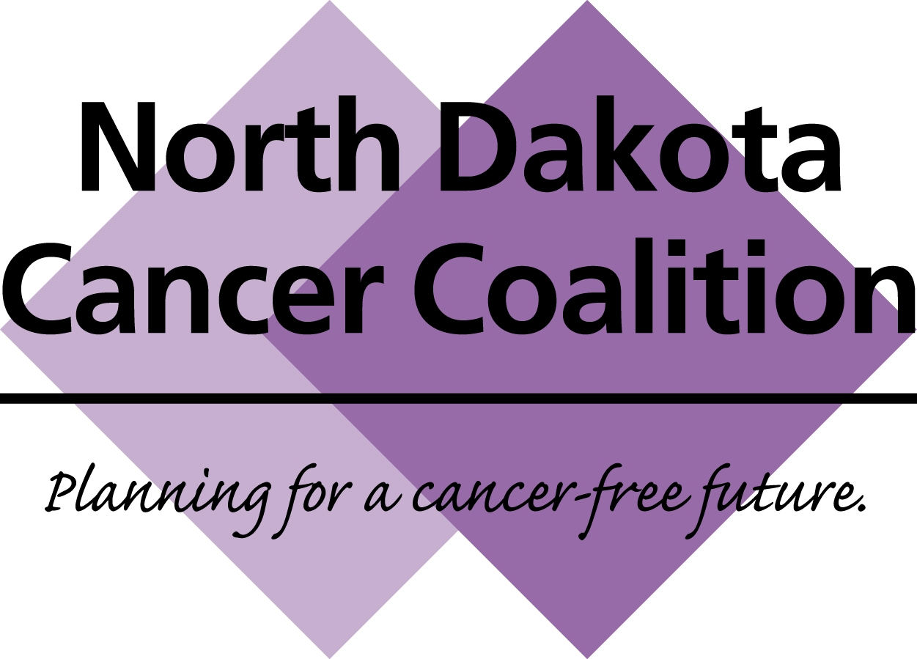
NORTH DAKOTA CANCER COALITION (NDCC)
CONFERENCE CALL
MONDAY October 15th, 2018
12:00 TO 1:00 P.M. Central time

MINUTES
- Roll Call –
  - Shannon Bacon – American Cancer Society
  - Stef Meyer – NDSU
  - Jodie Fetch – Custer Health
  - Joell Letzring – Essentia Health
  - Kevin Pavlish – Southwestern District Health Unit
  - Mallory Koshiol – Sanford Health
  - Rachel Ramsey – Pembina
  - DeAnn Miller – Nelson-Griggs District Health Unit
  - Susan Mormann – ND Department of Health
  - Connie Geyer – Minot State University
  - Jacob Davis – Prevent Child Abuse
  - Becky Bailey – Custer Health
  - Lisa Homan - Merck
  - Janna Pastir – ND Department of Health
  - Danni Pinnick - NDSU
  - Barb Steiner – ND Department of Health
  - Abbey Fraser – American Cancer Society
  - Pam Gahr – Essentia Health
  - Laurie Odden – American Cancer Society
  - Chad Ihla – ND Department of Health
  - Julie Garden-Robinson, NDSU
  - Beth Nelson, Altru Health
  - Jolene Keplin, Turtle Mountain Tribal Health Education
  - Gina Johnson, Great Plains Tribal Chairmen’s Health Board
  - Terri Rattler, Great Plains Tribal Chairmen’s Health Board

- Welcome- Mallory Koshiol, Chair

- Approval of Minutes from August- https://www.ndcancercoalition.org/member-information/meetings-minutes-notes/ Approved

- Treasurer’s Report- Geneal Roth, Treasurer

- New members- Shannon Bacon, Secretary

We welcome new members Cheryl Smith of Roger Maris Cancer Center and Becky Bailey of Custer Health

- Subcontracts Update – Dr. Jesse Tran, ND Dept of Health

- 15 contracts have been awarded. Blended funding from several programs. Most are supported by Comp Cancer, Immunization supporting 2, Women’s Way supporting 3, CRC Screening Initiative supporting 2. Contracts related to CRC, breast, cervical, screening/ed in general, nutrition and physical activity, HPV related, sun safety, and a couple related to radon.
- Next year: will be updating the way subcontracts are reviewed and awarded. Likely starting process at least a month earlier. Release RFPs sometime in May rather than June, just to give an extra bit of time as review process will be more lengthy with these new changes. If you are thinking about applying for subcontract next year, will be starting mid – late May and will give about a month for folks to work on applications.

- Breast Cancer Awareness Month

- Kate Syverson, Screening & Early Detection Workgroup Lead, shared that the workgroup wanted to bring forward information on what is happening in the state related to breast cancer screening, in honor of breast cancer awareness month. The Women’s Way program has influenced nationwide strategies related to patient navigation for BCCED programs, and this is something to celebrate. Barb Steiner and Susan Mormann of Women’s Way presented the details in their presentation, “Women’s Way & the Power of Patient Navigation.”
- About Women’s Way (information from Barb)
  - Breast and cervical cancer screening and diagnostic program. Funding comes from CDC.
  - This program has resulted in 318 women diagnosed with breast cancer. 380 women with cervical cancers or pre-cancers that have required treatment.
  - Medicaid Women’s Way treatment program – 168 uninsured women’s way clients to get treatment for breast cancer. Over 100 women got treatment for cervical cancer or pre-cance.r
  - Is available throughout ND. Contract with local public health departments or units.
  - 10 different coordinating units with local coordinators.
  - Eligibility, enrollment, and services were reviewed. Please see attached slides for details.
  - Women’s Way is contracted with BCBSND for claims. Providers send the claims to BCBSND, and the claims are processed through BCBSNSD.
  - If a woman is diagnosed with breast or cervical cancer but not eligible for other insurance, she may be eligible for “Women’s Way Medicaid,” including for maintenance treatment.

- Women’s Way & Patient Navigation Strategy (information from Susan)
  - 2017- 18 – screened 1,297 of the 1300 women that Women’s Way anticipated screening (99.8% achieved of goal!)
  - Susan reviewed how Women’s Way adapted after the change in healthcare landscape after Medicaid Expansion, including providing patient navigation to women with public and private health insurance that fall within Women’s Way income eligibility.
  - Eligible insured patients can now enroll in navigation-only services.

- New videos featuring ND patient stories – Paulette DeLeonardo, Women’s Way
    - Paulette has made several breast cancer awareness videos featuring local survivors. Please share these on social media using these links:
      - 1 in 8 WeVideo: http://www.ndhealth.gov/womensway/image/cache/1_in_8.mp4
      - IBC WeVideo: http://www.ndhealth.gov/womensway/image/cache/IBC.mp4

- Save the Date: NDCC all-member meeting, June 2019, more details coming soon. Please reach out if you’d like to be on planning committee

- Adjourn

