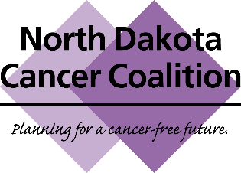
Annual Meeting
November 4, 2019
Conference Call
- Roll Call – Mallory, All
- Welcome – Mallory
  - Geneal: budget report
  - Welcome new members
- Review & Approve Annual Meeting Minutes – Mallory
  - New minutes are posted.
- Cancer Plan and Mid-Plan Review/Update – Jesse
  - A few have volunteered to help so far.
  - Reviewing and revising will take a few months.
  - Will review once again after sending off to graphics.
  - Look to have a finished product by June.
  - If anyone else would like to assist, please send to a leader (Mallory, Jesse, etc.).
- ND CRC Roundtable Update – Shannon
  - The roundtable was a large success with 60 people in attendance from around the state.
  - The national screening rate increased by 3% after having plateaued for years thanks to the efforts of the keynote speaker with the 80% in every community initiative.
  - The slides from the meeting will be made available.
  - ND is one of the most improved states, tied for first with Kentucky.
- Recap of 2019 Annual Meeting – Mallory
  - Brian Halvorson education
  - If you would like Brian to come to your location, NDCC can reimburse.
- 2019 – 2020 Priorities & Implementation Structure – Mallory
  - Update website to reflect new structure and align Coalition Member signup process.
  - The slides shown have been emailed to all members.
  - We are moving into a more flexible structure with time-limited Implementation Teams which come together for a specific project and then disband when deliverables are met.
  - Please consider joining one or more implementation team(s) and reach out to the leader if interested.
- Recap – Mallory
- Adjourn - Mallory

