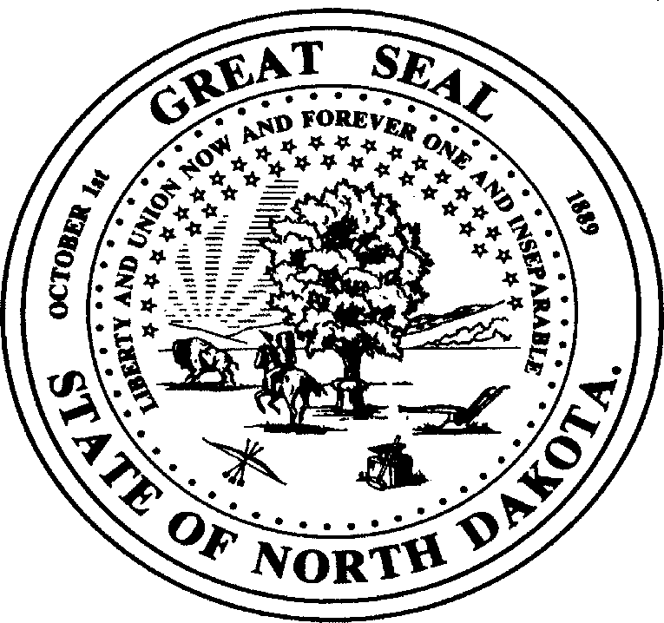 | DOCUMENT TITLE  DEPARTMENT OF HEALTH AND HUMAN SERVICES  DISEASE CONTROL AND FORENSIC PATHOLOGY  SFN ##### (M-YYYY)

Please complete the information that applies and FAX to701.328.0355 (Confidential)
If questions, call 701.328.2378 or 800.472.2180 (ND Only)
For Women Known to be HBsAg Positive  ☐ Administer hepatitis B immune globulin (HBIG) and hepatitis B vaccine within 12 hours of birth to all infants born to hepatitis B positive mothers. If infant doesn’t receive HBIG within 12 hours, it can be administered up to 7 days after birth. |  |  |  |  | For Women Whose HBsAg Status is Unknown  ☐ Perform a stat HBsAg screening test for all women admitted for delivery whose hepatitis status is unknown.  ☐ While test results are pending, the infant should receive hepatitis B vaccine within 12 hours of birth. If the mother is later found to be positive, her infant should receive the additional protection of HBIG as soon as possible and within 7 days of birth.
Note Only Report if Mother is HBsAg-positive
Name of Hospital |  |  |  |  |  | City of Hospital
Date Sent
MOTHER’S INFORMATION
Mother’s Hospital Record Number |  |  |  |  |  | Mother’s insurance status(i.e. private, Medicaid, uninsured)
HBsAg(+) Test Date
Last Name |  |  |  |  |  | First Name
Address |  |  |  |  |  | City/State
Zip Code | Telephone Number |  |  |  |  |  |  | Alternate Telephone No. (i.e., relative)
Date of Birth | Mother’s Country of Origin |  |  |  |  |  |  | Mother’s Preferred Language
Physician’s Name |  |  |  |  |  | Clinic Name
Race  ☐ White  ☐ American Indian/Alaska Native  ☐ Asian |  |  | ☐ Black/African American  ☐ Native Hawaiian or other Pacific Islander |  |  |  | ☐ Unknown  ☐ Other |  |  | Ethnicity  ☐ Hispanic or Latino  ☐ Not Hispanic or Latino  ☐ Unknown
INFANT’S INFORMATION
Infant’s Hospital Record Number |  |  |  |  |  | Insurance status(i.e. private, Medicaid, uninsured)
Infant’s Last Name |  |  |  |  |  | Infant’s First Name (if known)
Infant’s Sex  ☐ M ☐ F |  | Infant’s Birth Weight |  |  |  | Infant’s Date and Time of Birth
Date Hepatitis B Vaccine given |  |  |  | Time Hepatitis B Vaccine given |  |  |  |  | Date HBIG Given |  | Time HBIG Given
**IMPORTANT** Clinic Where Infant Will Receive HBV2
Name of Infant’s Pediatrician or PCP (include telephone number if known)
Race  ☐ White  ☐ American Indian/Alaska Native  ☐ Asian |  |  | ☐ Black/African American  ☐ Native Hawaiian or other Pacific Islander |  |  |  | ☐ Unknown  ☐ Other |  |  | Ethnicity  ☐ Hispanic or Latino  ☐ Not Hispanic or Latino  ☐ Unknown
Disease Control and Forensic Pathology Section 600 E Boulevard Ave., Dept 325
Bismarck, ND 58505-0250

