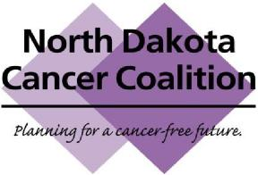
NORTH DAKOTA CANCER COALITION &
STEERING COMMITTEE MEETING SCHEDULE
January 2020 through December 2020
DATE | TENTATIVE TIME (CST) | IN PERSON OR  CONFERENCE CALL
Steering Committee  Monday, January 27 | 12:00 pm (noon) – 1:00 pm | Conference call
Coalition  Monday, February 10 | 12:00 pm (noon) – 1:00 pm | Conference Call
No Meetings or Conference
Calls Scheduled in March
Steering Committee  Monday, April 27 | 12:00 pm (noon) – 1:00 pm | Conference Call
Coalition  Monday, May 18 | 12:00 pm (noon) – 1:00 pm | Conference Call
Annual Business Meeting Tentative: Thursday, July 16 | 9:00am – 2:00pm | In-Person Meeting  Bismarck
Coalition  Monday, August 24 | 12:00 pm (noon) – 1:00 pm | Conference Call
Steering Committee  Friday, September 11 | All day  9:30 am to 4:00 pm | In-Person Meeting  Jamestown
Coalition  Monday, October 26 | 12:00 pm (noon) – 1:00 pm | Conference Call
Steering Committee  Monday, November 23 | 12:00 pm (noon) – 1:00 pm | Conference Call

