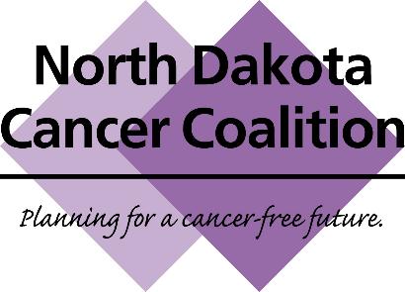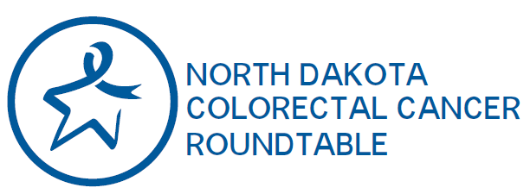

Joint Conference Call/Webex
February 4, 2019, 12-1pm CST
MINUTES
- Roll Call – 54 attendees were recorded:
Jolene Keplin | Turtle Mountain Tribal Health Education
Matthew Stancyk | Altru Health
Beverly Greenwald | DOT Physicals LLC
Kjersti Hintz | Bismarck Burleigh Public Health
Caleb Lavell | National Colorectal Cancer Roundtable
Shawn Morlock | St. Alexius
Abby Muggerud | KAT Marketing
Julie Ferry | Nelson-Griggs District Health Unit
Midge Birkholz | Altru Health
Sarah Scott | ND Department of Health
Paulette DeLeonardo | ND Department of Health
Erin Powers | Family HealthCare
Amy Keller | ND Dept of Health – Comp Cancer
Dawn McCollum | Family HealthCare
Wanda Rosenquist | Altru Health
Jodie Fetsch | Custer Health
Pam Gahr | Essentia Health
Chad Ratigan | Great Plains Tribal Chairmen’s Health Board
Chad Ihla | ND Dept of Health
Becky Bailey | Custer Health
Kim Kuhlmann | American Cancer Society Cancer Action Network
Barb Steiner | ND Women’s Way
Dave Dondoneau | Run For Your Buns
Rebecca Baron | Mid Dakota Clinic
Danielle Pinnick | NDSU
Laurie Odden | American Cancer Society
Melodi Krank | Sanford Health
Chastity Dolbec | Coal Country Community Health Centers
Donald Warne | UND School of Medicine & Health Sciences
Janna Pastir | ND Department of Health, Chronic Disease
Beth Nelson | Altru Health
Terri Gustafson | Cavalier County District Health Unit
Tinka Duran | Great Plains Tribal Chairmen’s Health Board
Julie Garden-Robinson | NDSU Extension
Eugene Giago | Great Plains Tribal Chairmen’s Health Board
Patricia Ness | West River Health Services
Becky Wahl | Community HealthCare Association of the Dakotas
Cindy Gohner | Blue Cross Blue Shield of ND
Sara Anderson | Sanford Health Plan
Betty Housey | Valley Community Health Centers
Tessi Ross | Sanford Health
Susan Mormann | ND Department of Health
Joell Letzring | Essentia Health
Betsy Kanz | Bismarck Burleigh Public Health
Jacob Davis | Prevent Child Abuse ND
Kate Syverson | Sanford Health
Lisa Edholm-Moch | Emmons County Public Health
Holly Benjamin | Altru Health
Cristina Oancea | UND, Cancer Registry
Melissa Klein | Bismarck Cancer Center
Yun Zheng | UND, Cancer Registry
Mallory Koshiol | Sanford Health, NDCC
Shannon Bacon | American Cancer Society
Geneal Roth | Quality Health Associates

- Welcome – Dr. Donald Warne, ND Colorectal Cancer Roundtable Chair
- Standing items (North Dakota Cancer Coalition) – Mallory Koshiol, ND Cancer Coalition Chair
  - Approval of October, 2018, meeting minutes - -- Approved
  - Treasurer’s Report – Geneal Roth
    - The North Dakota Cancer Coalition currently has $10,190.71. A donation of $151 was made since last meeting.
  - New Members: (Welcome to the NDCC!)
    - Annette Groves, Lake Region District Health Unit
    - Laura Spicer, Valley Health
    - Amy Keller, North Dakota Department of Health Comp Cancer
    - Chans Brown, YMCA of Cass and Clay Counties
    - Kayla Carlson, NDSU Extension
    - Annie Clark, Sanford Health
  - Save the Date: The North Dakota Cancer Coalition annual meeting will take place in-person June 13th, 2019, from 12:30 – 4pm in Minot, immediately following the Dakota Conference. Lunch and Nursing CEU’s will be provided. Watch your email for registration link, coming soon.

- 80% in Every Community – Campaign kick off! – Caleb Levell, Program Manager, National Colorectal Cancer Roundtable (NCCRT)
- Caleb Lavell of the National Colorectal Cancer Roundtable helped us look back and reflect on the progress made during the 80% by 2018 campaign, and he shared about what to expect from the new 80% in Every Community Campaign. North Dakota was one of the states which saw the most improvement in CRC screening, although 35% of our eligible state population is still unscreened. Caleb noted that nationwide, community health centers saw a 12% improvement during the campaign, and the Medicare population saw a 9% improvement. Still, not all communities have benefited equally from the improvements. The new campaign will focus on ensuring that 80% can be attained for every community. See his slides (attached) for additional details, and watch for more information about the new campaign in March.

- Gearing Up for Colorectal Cancer Awareness Month:
  - Health System Tools – Tessi Ross, Sanford Health
    - FAQ Documents for Clinical Settings:
      - Answering Patient Questions
      - Answering Common Clinician Questions
    - Sample Email from Health System to Staff

  - Public Awareness Tools – Shannon Bacon, American Cancer Society
    - 2019 ND CRC Month Social Media Toolkit, featuring ND stories
      - We encourage you to share this with the person who manages social media at your organization, to help them get a head start planning for March.
    - Turn ND Blue Photo Contest - Photo Contest Details
      - Photos will be accepted March 1 – April 2nd.
      - Start thinking of a theme now, and schedule a time for your group to take a photo. Everyone should wear some sort of blue, and you should include a message to promote screening.
      - We will again be accepting photos in the categories of: Community & Education Groups; Hospitals; Non-Medical Worksites; and Other Direct Patient Care Organizations.
    - Sample Email from Employer to Staff – CRC Month Announcement
      - KAT Marketing has volunteered to promote this to area chambers.
  - Tools for sharing local data – Jesse Tran, ND Department of Health
    - ND CRC Data Factsheet
    - ND State Profile on CRC Screening (CDC)

- 2019 North Dakota Legislative Update – Kim Kuhlmann, American Cancer Society Cancer Action Network
  - Kim Kuhlmann gave an update from ACS CAN on cancer-related legislation. Several tobacco-related bills are being tracked closely – looking at tobacco tax increase (funds would support health-related efforts), e-cigarette regulation. Funding for the state colorectal cancer initiative and women’s way is expected to pass at this time. Several insurance-related bills are being tracked. Medicaid expansion is up for re-authorization, and it is anticipated that it will be re-authorized. ACS CAN is asking for it to be re-authorized with no future re-authorizations needed. To learn more, contact kimberly.kuhlmann@cancer.org

- How to get involved with NDCC or ND CRC Roundtable – Mallory Koshiol, NDCC Chair
  - North Dakota Cancer Coalition:
    - Workgroups: Screening & Early Detection; Treatment & Survivorship; HPV Taskforce
    - Learn more at: www.ndcancercoalition.org
      - Click “Join Us” if you are not currently on listserv
    - Questions? Contact ndcc@nd.gov
  - ND Colorectal Cancer Roundtable
    - Workgroups: Provider Education & Public Awareness
    - Learn more at: http://www.ndhealth.gov/compcancer/cancer-programs-and-projects/80-by-2018
    - Questions? Contact shannon.bacon@cancer.org or jtran@nd.gov

- Adjourn

