Check Off When Completed

MFP Brochure
MFP Rights Brochure
MFP Fact Sheet
MFP Informed Consent Document
Guardianship Expectations Document
MFP Supplemental Services Request Form
MFP Role Matrix
MFP Process Directions Nursing Facility ICF/MR
Assistive Technology Assessment and Referral Information

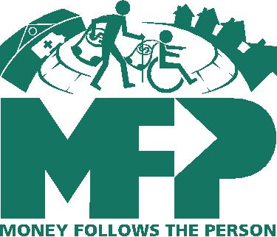
DEVELOPMENTAL CENTER TRANSITION PROCESS GUIDELINE CHECKLIST

- Developmental Center (DC) Support Team (including DD Case Manager) completes Resident Decision Profile and recommends transition to a community setting-MFP Qualified Community Residence.

- DC Social Worker provides resident and/or legally authorized decision maker with the Money Follows the Person Grant (MFP) brochure, Role Matrix, MFP Rights brochure, Guardianship Expectation Document, and answers any questions about grant participation.

- If a guardian is involved, DC Social Worker will review their past involvement with the consumer to determine if the guardian has been actively involved over the past six months. The nature of the relationship will be documented in the Consumer’s file.

- DC Social Worker secures MFP consent to participate

- Copies provided to: Resident/decision maker; MFP Grant Program Administrator, and DD Case Manager

- DD Case Manager will complete PAR assessment including ICF/MR level of Care review.

- DD Case Manager will work with all team members to develop the ISP documenting support services to be provided in the community.

- DD Case Management, Identified community provider team, and DC staff team will complete and/or communicate assessment information and work together to establish a transition plan that will include a Risk Mitigation Assessment/Plan and a 24 Hour Backup Plan prior to transition to a qualified MFP residence in the community.

- The DC staff will work with the community residential provider to secure information needed to submit a Supplemental Services Request Form.

- Community Provider will submit Supplemental Services Request Form to the MFP Program Administrator for Approval and arrange for all items approved.

- Resident will transition to the community.

- DD Case Manager will provide ongoing follow-up case management support.

