MFP PARTICIPANT INFORMATION
Last Name | First Name | Referral Date
Address |  | Telephone Number
City | State | ZIP Code
DENIAL OF SERVICE(S)
It has been determined that you are not eligible for grant services or grant services will be terminated because of the following reason(s):
Does not meet 3 month institutionalization requirement of grant
Does not meet institutional Level of Care requirement of the grant
Does not meet Medicaid eligibility requirement of the grant
Health, welfare, and safety needs cannot be met in the community.
Other

TERMINATION OF SERVICES
Completion of the 365 days of demonstration grant eligibility
Has been institutionalized for more than 30 days and is not planning a return to the community
Health, welfare, and safety needs cannot be met in the community.
Other
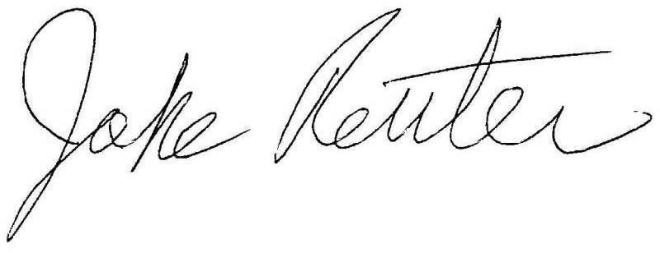
MFP Grant Program Administrator Signature |  | Date

If you disagree with this decision, please contact the Money Follows the Person Program Manager at 701-328-4090 or N.D. Department of Human Services, 600 E Boulevard Avenue, Dept. 325, Bismarck, ND 58505-0250
If a participant in the MFP demonstration grant has a complaint or concern, every effort will be made to deal with the issue on an informal basis or with a referral to an advocacy group such as the ND Protection and Advocacy Office.

You may appeal this decision to the ND Department of Human Services Appeals Supervisor within 30 days from the receipt of this notice. The purpose of this hearing is for you to show that a mistake or error was made in this decision. The appeal request should be made in writing and sent to:

Appeals Supervisor, Legal Advisory Unit, N.D. Department of Human Services,
600 E Boulevard Avenue, Dept. 325, Bismarck, ND 58505-0250,
Phone: (701) 328-2311, Toll Free: (800) 472-2622, email: dhslau@nd.gov

You may represent yourself in an appeal or you may be represented by an attorney, a relative, a friend, or other spokesperson.

