# [**30 Days of Holiday Fun**](https://prevention.nd.gov/node/888)

30 days of Holiday fun Provides parents with 30 days of fun to enhance their relationship with their children.

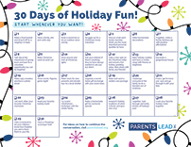

# *[**30-Day Parent Challenge**](https://prevention.nd.gov/materials/30-day-parent-challenge)

Provides parents with 30 tips for how to enhance the relationship with their children. Request printed handouts or download a PDF.

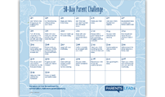

# [**30-Day Parent Challenge: For the New Year**](https://prevention.nd.gov/node/882)

Provides parents with 30 tips for how to enhance the relationship with their children. Request printed handouts or download a PDF.

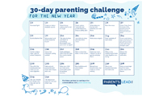

# *[**Activity Book**](https://prevention.nd.gov/materials/activity-book)

This activity book is designed to reinforce underage drinking prevention efforts among youths.

Top of Form

Bottom of Form

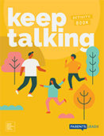

# [**Adverse Childhood Experiences**](https://prevention.nd.gov/materials/adverse-childhood-experiences)

This Parents LEAD for professionals handout provides an overview of Adverse Childhood Experiences (ACE).

Top of Form

Bottom of Form

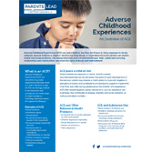

# [**Behavioral Health Continuum of Care Model**](https://prevention.nd.gov/node/698)

This handout provides an overview of the signs and symptoms of methamphetamine use and withdrawal as well as common street names and methods of use.

Top of Form

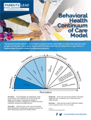

# *[**Being Kind Activity Book**](https://prevention.nd.gov/node/871)

An activity book filled with activities focused on fostering kindness to help teach children how to recognize and stand up to bullying behavior, as well as be aware of their own actions towards others.

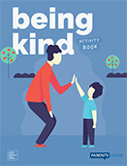Top of Form

# [**Billboard - Your Influence. Not Alcohol's.**](https://prevention.nd.gov/materials/billboard-your-influence-not-alcohols)

Designed to reinforce underage drinking prevention efforts among youth.

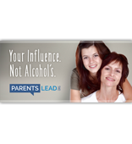

# [**Bingo Card**](https://prevention.nd.gov/node/883)

Did you know by increasing your child’s protective factors you are helping prevent multiple behavioral health-related issues? Try out this Family Bingo Challenge to “black-out” those behaviors!

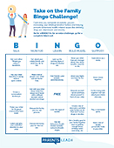

# *[**Building Character Activity Book**](https://prevention.nd.gov/node/872)

An activity book designed to help children identify, monitor, and adapt their emotional responses, as well as build up positive self-esteem!

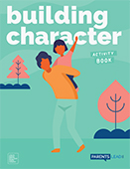

# *[**Building Resiliency**](https://prevention.nd.gov/materials/building-resiliency)

Provides parents with tips on what they can do to build resiliency on their kids.

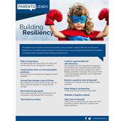Top of Form

# [**Children of Alcoholics**](https://prevention.nd.gov/materials/children-alcoholics)

This Parents LEAD for professionals handout provides an overview of Children of Alcoholics.

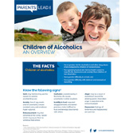

# [**Children’s Exposure to Domestic Violence**](https://prevention.nd.gov/node/694)

Professionals can play a critical role in assisting domestic violence victims and their children. This document provides information about signs and symptoms of children’s exposure to domestic violence and several steps to consider to better serve individuals and families experiencing domestic violence.

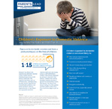Top of Form

# [**Coaster - Version 1**](https://prevention.nd.gov/materials/coaster-version-1)

Designed to reinforce underage drinking prevention efforts among youth.

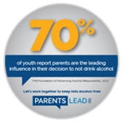

# [**Coaster - Version 2**](https://prevention.nd.gov/materials/coaster-version-2)

Designed to reinforce underage drinking prevention efforts among youth.

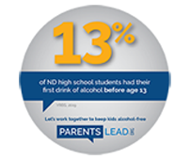Top of Form

# [**Coaster - Version 3 (Square)**](https://prevention.nd.gov/materials/coaster-version-3-square)

Designed to reinforce underage drinking prevention efforts among youth.

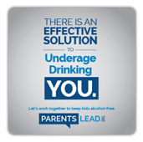Top of Form

# *[**Communicating With Your Child When You Suspect Substance Use**](https://prevention.nd.gov/materials/communicating-your-child-when-you-suspect-substance-use)

Creating a conversation with children is an effective way to prevent underage drinking.

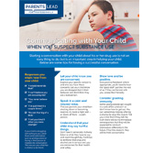

# *[**Confronting the Myths About Marijuana**](https://prevention.nd.gov/node/692)

Confronting the myths related to marijuana is essential to provide your child with an accurate view of the harm related to marijuana use.

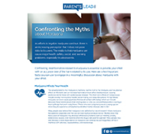

# [**Cyberbullying: The Basics**](https://prevention.nd.gov/materials/cyberbulling-basics)

Cyberbullying can start with a simple message and quickly spiral out of control. It can happen anywhere at any time.

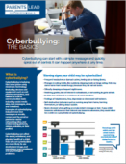Top of Form

# *[**Do You Know the Law?**](https://prevention.nd.gov/materials/do-you-know-law)

Provides information on North Dakota underage drinking laws.

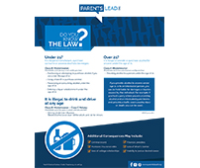

# *[**Door Openers vs Door Slammers**](https://prevention.nd.gov/materials/door-openers-vs-door-slammers)

When talking with your child, use the following ‘Door Openers’ to keep communication open and non-judgmental.

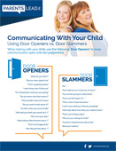

# [**Eight Dimensions of Wellness**](https://prevention.nd.gov/node/709)

Making the eight dimensions of wellness part of daily life can improve mental and physical health for individuals with mental health and/or substance use disorders.

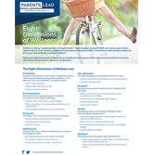Top of Form

# [**Encouraging Your Child to Hope**](https://prevention.nd.gov/node/874)

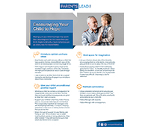

# [**Home Alone: Is Your Child Ready?**](https://prevention.nd.gov/materials/home-alone-your-child-ready)

Provides tips for parents on how recognize when their child is old enough to stay home alone.

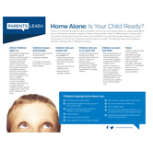Top of Form

# *[**Identifying Signs of Stress in Your Children and Teens**](https://prevention.nd.gov/materials/identifying-signs-stress-your-children-and-teens)

Young people, like adults, experience stress. This handout provides tips for parents on how recognize signs of stress in their kids.

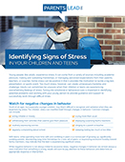

# [**Influence Your Kids - Extra Large Poster**](https://prevention.nd.gov/materials/influence-your-kids-extra-large-poster)

Designed to reinforce underage drinking prevention efforts among youth.

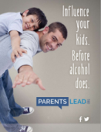

# [**Influence Your Kids. Before Alcohol Does. (11x17)**](https://prevention.nd.gov/materials/influence-your-kids-alcohol-does-11x17) or (8.5x11)

Designed to reinforce underage drinking prevention efforts among youth.

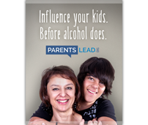Top of Form

# *[**Keep Talking - Conversation Starters**](https://prevention.nd.gov/materials/keep-talking-conversation-starters)

Encourages ongoing parent-child communication by providing cut-out conversation starters.

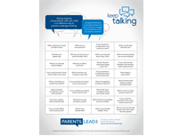Top of Form

# [**Keys to Prevention: Grades 10-12**](https://prevention.nd.gov/materials/keys-prevention-grades-10-12-0)

Your teenager is starting to develop his/her own identity and balance new freedoms. with that new freedom arises more opportunities for your teen to be exposed to high-risk behavior, specifically alcohol use and other drugs. Continue to share your expectations and opinions; they matter to you child, even if it doesn't always seem that way.

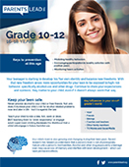

# [**Keys to Prevention: Grades 4-6**](https://prevention.nd.gov/materials/keys-prevention-grades-4-6)

This age is perhaps the most important time for parents to focus on prevention. During these later elementary school years, youth are beginning to be presented with opportunities to make choices about alcohol and drugs.

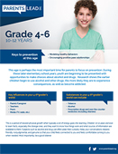Top of Form

# [**Keys to Prevention: Grades 7-9**](https://prevention.nd.gov/materials/keys-prevention-grades-7-9)

Young teens may say they don't need your guidance, but they are much more open to it than they'll ever let on. Make sure you talk to them about their choice of friends because alcohol and drug use in teens starts as a social behavior.

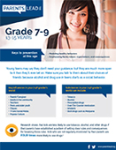Top of Form

# [**Keys to Prevention: K-3**](https://prevention.nd.gov/materials/keys-prevention-kindergarden)

Discussions about alcohol and other drugs must be in the here and now and related to people and events to child knows about.

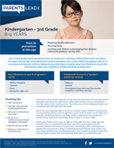Top of Form

# [**Keys to Prevention: Preschool**](https://prevention.nd.gov/materials/keys-prevention-preschool)

The attitudes and habits children from at this age will have an important bearing on the decisions they will make regarding substance use when they are older.

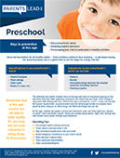

# [**Keys to Prevention: Toddler**](https://prevention.nd.gov/node/695)

At this age, your child learns about the world though watching, listening, touching and manipulating.

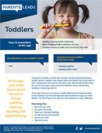Top of Form

# [**Maintaining Healthy Levels of Stress in Your Children**](https://prevention.nd.gov/materials/maintaining-healthy-levels-stress-your-children)

While some amount of stress is normal and should be expected, an overwhelming amount of stress can be unhealthy and quickly take a toll on a child’s developing mind and body.

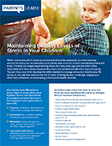Top of Form

# [**Managing Anxiety as School Starts**](https://prevention.nd.gov/node/881)

As COVID numbers are surging in the state, children and parents may be experiencing anxiety about this school year. 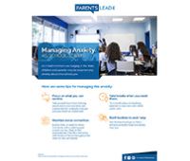

# [**Media Use & Your Child**](https://prevention.nd.gov/materials/media-use-your-child)

Studies show that children who watch five or more hours of TV per day are much more likely to try cigarettes and alcohol.

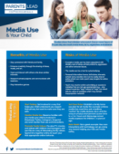Top of Form

# [**Monitoring: Staying in Touch**](https://prevention.nd.gov/materials/monitoring-staying-touch)

Monitoring is an important way to reduce the changes that your child will use alcohol and drugs. 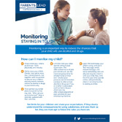

Top of Form

Bottom of Form

# * [**Newsletter Insert: Preventing Underage Drinking**](https://prevention.nd.gov/materials/newsletter-insert-preventing-underage-drinking)

Designed to reinforce underage drinking prevention efforts among youth.

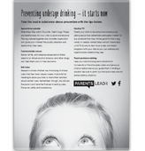

# *[**Parent Self-Assessment**](https://prevention.nd.gov/materials/parent-self-assessment)

Provides parents an idea of how their actions may contribute to their child's likelihood of underage drinking.

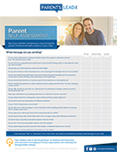Top of Form

# [**Parenting During the Holidays**](https://prevention.nd.gov/node/889)

As we enter the holiday season, we are reminded of the importance of hope, empathy and gratitude. As parents, we have an opportunity to shape this event for our children, ensuring they look back and identify gains more than losses. 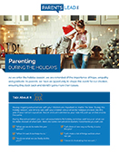

# [**Parenting is Powerful Dad Magnet**](https://prevention.nd.gov/node/863)

Parenting is Powerful. Keep a reminder in eyesight with our Parents Lead magnets.

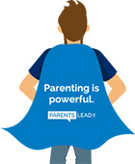Top of FormBottom of Form

# [**Parenting is Powerful Mom Magnet**](https://prevention.nd.gov/node/862)

Parenting is Powerful. Keep a reminder in eyesight with our Parents Lead magnets.

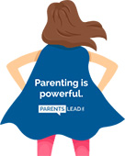

# *[**Parents Lead Table Tent**](https://prevention.nd.gov/materials/parents-lead-table-tent)

Designed to reinforce underage drinking prevention efforts among youth.

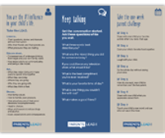

# *[**Parents: Reducing Youth Access to Alcohol**](https://prevention.nd.gov/node/714)

Parents play a critical role in whether their children choose to drink alcohol underage. This flyer highlights strategies for reducing youth access to alcohol and the different underage drinking laws for adults.

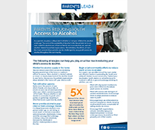

# *[**Playing Cards - Version 1**](https://prevention.nd.gov/node/853)

Full set of playing cards (54 cards including jokers) contains everyday conversation starters on each card to encourage ongoing parent-child communication.

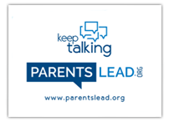Top of Form

Bottom of Form

# [**Playing Cards - Version 2**](https://prevention.nd.gov/materials/playing-cards-version-2)

Full set of playing cards (54 cards including jokers) contains everyday conversation starters on each card to encourage ongoing parent-child communication.



Top of Form

Bottom of Form

# [**Playing Cards - Version 3**](https://prevention.nd.gov/node/856)

Full set of playing cards (54 cards including jokers) contains everyday conversation starters on each card to encourage ongoing parent-child communication.

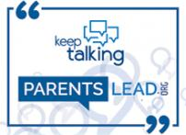

# [**Preparing for Deployment: Supporting Your Child's Behavioral Health**](https://prevention.nd.gov/node/690)

Parent military deployment can be a difficult time of transition for children and families. This handout provides tips for parents on how to help prepare their child before parent deployment as well as signs of separation anxiety that might appear once the deployment has begun.

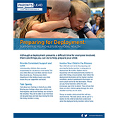Top of Form

# [**Promoting Healthy Teen Dating Relationships**](https://prevention.nd.gov/node/850)

Parents play an important role in teaching teens about healthy relationships. This handout highlights the characteristics of a healthy dating relationship and five simple ways parents can promote them with their teen.

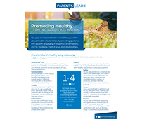Top of Form

# [**Protect Your Kids - Safe Use of Medication**](https://prevention.nd.gov/materials/protect-your-kids-safe-use-medication)

A postcard with sample conversations on how to teach your children about medicine safety.

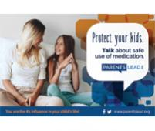Top of Form

# [**Recovery**](https://prevention.nd.gov/materials/recovery)

Recovery is a process of change through which individuals improve their health and wellness, live a self-directed life, and strive to reach their full potential.

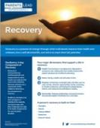

# [**Recovery Housing**](https://prevention.nd.gov/node/711)

This handout highlights the five primary characteristics on recovery housing, a recovery-oriented supportive living environment for individuals wanting to initiate and sustain recovery.

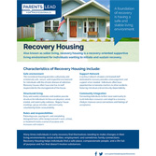

# [**Red Ribbon Week 2017**](https://prevention.nd.gov/materials/red-ribbon-week-2015)

Red Ribbon Week is the oldest and largest drug prevention program in the Nation and a way for people and communities to take a visible stance against drugs.

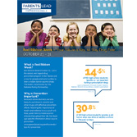

# *[**Reducing Your Child's Risk for Substance Use**](https://prevention.nd.gov/materials/reducing-your-childs-risk-substance-use)

Provides parents with tips on how to reduce their children risk for substance use.

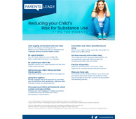

# *[**Signs & Symptoms in the Classroom**](https://prevention.nd.gov/materials/signs-symptoms-classroom)

Provides tips for educators on how recognize signs that may indicate that a student is misusing alcohol or other drugs.

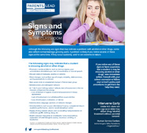Top of Form

Bottom of Form

# *[**Signs & Symptoms: Alcohol**](https://prevention.nd.gov/materials/signs-symptoms-alcohol)

Any of the following signs/symptoms may be cause for concern. If behaviors continue, you may want to seek professional assistance.

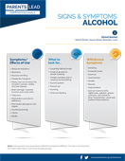

# [**Signs & Symptoms: Cocaine**](https://prevention.nd.gov/materials/signs-symptoms-cocaine)

Any of the following signs/symptoms may be cause for concern. If behaviors continue, you may want to seek professional assistance.

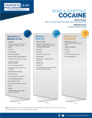

# [**Signs & Symptoms: Heroin**](https://prevention.nd.gov/materials/signs-symptoms-heroin)

Any of the following signs/symptoms may be cause for concern. If behaviors continue, you may want to seek professional assistance.

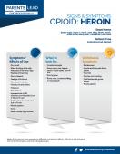Top of Form

# [**Signs & Symptoms: Inhalants**](https://prevention.nd.gov/materials/signs-symptoms-inhalants)

Any of the following signs/symptoms may be cause for concern. If behaviors continue, you may want to seek professional assistance.

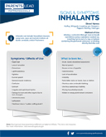

# [**Signs & Symptoms: Ketamine**](https://prevention.nd.gov/materials/sign-symptoms-ketamine)

Any of the following signs/symptoms may be cause for concern. If behaviors continue, you may want to seek professional assistance.

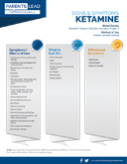

# [**Signs & Symptoms: LSD**](https://prevention.nd.gov/materials/signs-symptoms-lsd)

Any of the following signs/symptoms may be cause for concern. If behaviors continue, you may want to seek professional assistance.

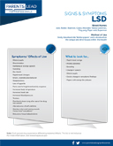

# [**Signs & Symptoms: Marijuana**](https://prevention.nd.gov/materials/signs-symptoms-marijuana)

Any of the following signs/symptoms may be cause for concern. If behaviors continue, you may want to seek professional assistance.

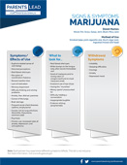

# [**Signs & Symptoms: MDMA (Ecstacy)**](https://prevention.nd.gov/materials/signs-symptoms-mdma-ecstacy)

Any of the following signs/symptoms may be cause for concern. If behaviors continue, you may want to seek professional assistance.

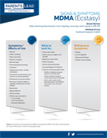

# [**Signs & Symptoms: Methamphetamine**](https://prevention.nd.gov/node/699)

This handout provides an overview of the signs and symptoms of methamphetamine use and withdrawal as well as common street names and methods of use.

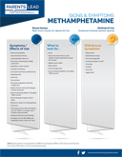

# [**Signs & Symptoms: Over the Counter Drugs**](https://prevention.nd.gov/materials/signs-symptoms-over-counter-drugs)

Any of the following signs/symptoms may be cause for concern. If behaviors continue, you may want to seek professional assistance.

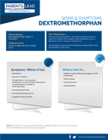

# [**Signs & Symptoms: Prescription Depressants**](https://prevention.nd.gov/materials/signs-symptoms-prescription-depressants)

Any of the following signs/symptoms may be cause for concern. If behaviors continue, you may want to seek professional assistance.

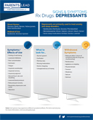

# *[**Signs & Symptoms: Prescription Opioids**](https://prevention.nd.gov/materials/signs-symptoms-prescription-opioids)

Any of the following signs/symptoms may be cause for concern. If behaviors continue, you may want to seek professional assistance.

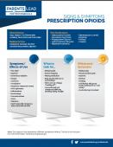

# *Top of Form[**Signs & Symptoms: Prescription Stimulants**](https://prevention.nd.gov/materials/signs-symptoms-prescription-stimulants)

Any of the following signs/symptoms may be cause for concern. If behaviors continue, you may want to seek professional assistance.

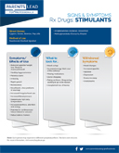

# [**Signs & Symptoms: Rohypnol**](https://prevention.nd.gov/materials/signs-symptoms-rohypnol)

Any of the following signs/symptoms may be cause for concern. If behaviors continue, you may want to seek professional assistance.

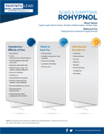

# [**Signs & Symptoms: Synthetic Drugs**](https://prevention.nd.gov/materials/signs-symptoms-synthetic-drugs)

Any of the following signs/symptoms may be cause for concern. If behaviors continue, you may want to seek professional assistance.

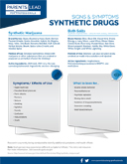

# [**Stages of Change**](https://prevention.nd.gov/materials/stages-change)

Change is not single event; it is a process involving a variety of steps. When a person goes through treatment and recovery, they usually transition through the "Stages of Change"

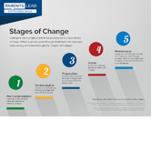

# [**Starting the School Year: Reducing the Risk of Underage Drinking**](https://prevention.nd.gov/materials/starting-school-year-reducing-risk-underage-drinking)

A key risk period for underage drinking or drug use is during times of transition like the start of a new school year. The tips on this handout provide parents or guardians with ways to help children reduce any stress or anxiety associated with the new school year by preparing them for what to expect or how to confront uncomfortable or dangerous situations.

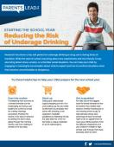Top of Form

# *[**Staying Safe Online Activity Book**](https://prevention.nd.gov/node/857)

The activity book contain fun and engaging activities for children while teaching the basics of online safety.

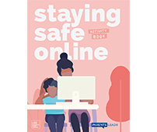Top of Form

# [**Substance Exposed Newborns: An Introduction to Solutions**](https://prevention.nd.gov/node/696)

The five-point intervention framework to address the system surrounding substance exposed newborns illustrates five major time frames when intervention in the life of an infant can help reduce the potential harm of prenatal substance exposure. This handout provides a summary of this framework.

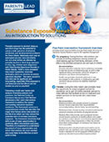

# [**Substance Exposed Newborns: Signs, Symptoms, and Best Practices for Mother and Baby**](https://prevention.nd.gov/node/741)

Substance Exposed Newborns are infants affected by prenatal exposure to substances such as prescribed medications, alcohol, illicit drugs, and tobacco. This handout illustrates different signs and symptoms of substance exposed newborns and best practices for treating both pregnant mother and substance exposed newborn.

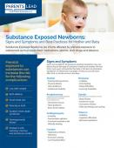

Top of Form

# [**Supporting Your Loved One in Treatment**](https://prevention.nd.gov/node/772)

Substance abuse affects the whole family, not just the individual who is addicted.

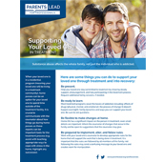Top of Form

# *[**Talking to Your Child about Marijuana**](https://prevention.nd.gov/node/693)

Youth are viewing marijuana more positively and believe marijuana use is not dangerous, but talking openly and honestly with youth about marijuana is one of the most effective ways to prevent them from using it.

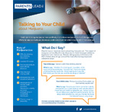Top of Form

# *[**Teen Suicide: Identifying Warning Signs and Ways to Respond**](https://prevention.nd.gov/node/739)

Parents, friends, and other trusted adults are in a key position to identify the signs of teen suicide and get help. This document highlights the key risk factors and warning signs of teen suicide and ways to respond.

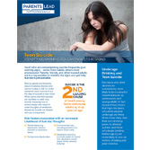Top of Form

# [**The Basics of Hope**](https://prevention.nd.gov/node/873)

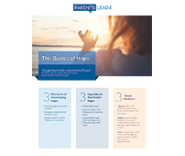

# [**Tips for Successful Communication**](https://prevention.nd.gov/materials/tips-successful-communication)

Having ongoing, effective conversations with your child is important, but can be difficult. Here are some tips to ensure your conversations are meaningful.

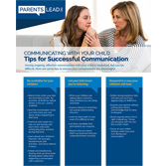

# [**Tips to Prevent Sexting for Teens**](https://prevention.nd.gov/node/717)

Sexting can expose teens to a variety of social, emotional, and legal risks. This handout provides information about sexting, its social, emotional and legal risks, and a variety of tips for parents and loved ones to start the conversation. 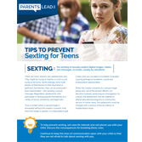Top of Form

# [**Underage Drinking Meets Its Match. You. (11x17)**](https://prevention.nd.gov/materials/underage-drinking-meets-its-match-you-11x17) or (8.5x11)

Designed to reinforce underage drinking prevention efforts among youth.

Top of Form

Bottom of Form

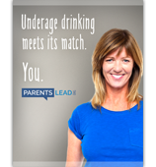

# [**Underage Drinking Meets Its Match. You. (11x8.5)**](https://prevention.nd.gov/materials/underage-drinking-meets-its-match-you-11x85)

Designed to reinforce underage drinking prevention efforts among youth.

Top of Form

# *[Underage Drinking Meets its Match: Tips for Parents](https://prevention.nd.gov/materials/underage-drinking-meets-its-match-tips-parents)

Provides tips for parents on how to take the lead in preventing underage drinking.

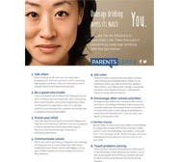

# [Understanding Eating Disorders](https://prevention.nd.gov/node/740)

Eating disorders, including Anorexia Nervosa, Bulimia Nervosa, and Binge-Eating Disorder, are treatable medical illnesses. This document provides information on the observable signs and symptoms of these disorders, possible health consequences, treatment approaches, and strategies for talking to a loved one experiencing an eating disorder.

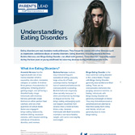

# [Using Medication to Treat Opioid Addiction](https://prevention.nd.gov/materials/using-medication-treat-opioid-addition)

Medication assisted treatment is an effective method for achieving recovery.

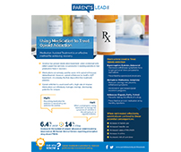

# [Video Games and Your Child](https://prevention.nd.gov/materials/video-games-and-your-child)

Video games and your child when it can become a problem and how to reduce the risk.

[Download pdf](https://prevention.nd.gov/file/33158/download?token=yHEVQJQq)



# [Warning Signs Your Child is Being Affected by Bullying](https://prevention.nd.gov/node/887)

All children that may be involved in bullying, whether they are the child being bullied, bullying others or seeing others being bullied, can be affected. It is important that you support all children involved to ensure it doesn’t continue and the issue is addressed.

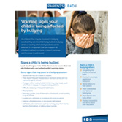

# [Your Influence. Not Alcohol's. (11x17)](https://prevention.nd.gov/materials/your-influence-not-alcohols-11x17)

Designed to reinforce underage drinking prevention efforts among youth.

[Download pdf](https://prevention.nd.gov/file/1282/download?token=KfW4_pEq)

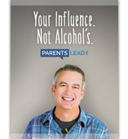

# *[Your Rights as a Parent](https://prevention.nd.gov/materials/your-rights-parent)

It is important to show respect for your child’s privacy; however, if you have concerns for their safety or well-being, you have the right to take action.

