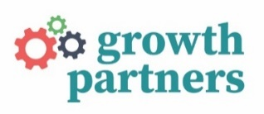
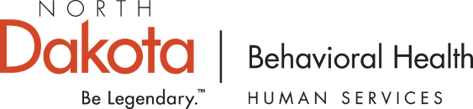

North Dakota Prevention Professionals Meeting
March 11–12, 2024

Meeting Participants
Grantees
- Cavalier County Health District: Stephanie Welsh
- Central Valley Health District: Shannon Klatt
- City-County Health District: Meghan Velure
- Devils Lake: Cindy Schmidt
- Dickey County Public Health District: Abby Gibbs
- Fargo Cass Public Health: Robyn Litke Sall
- First District Health Unit: Jen Clark, Jenny Lemasters
- Foster County Public Health: Robin Simonson
- Lake Region District Health: Lori Stevenson
- Grand Forks: Bill Vasicek
- LaMoure County Public Health: Kris Piehl, Jessica Duffy
- Ransom County Public Health: Cayla Wiltse
- Richland County Health Department: Lindsey Bommersbach
- Rolette County Public Health District: Barbara Feydenlund, Jennifer Tandeski, Sarah Senger
- Sargent County District Health Unit: Vanessa Bayger, Brenda Peterson
- Southwestern District Health Unit: Karen Goyne
- Spirit Lake Tribal Health: Mardell Merrick
- Standing Rock: Tami Birdshorse
- Steele County Public Health: Hannah Zamora
- Three Affiliated Tribes (NHA Nation): Hank Richardson
- Towner County Health Unit: Annie Mastrian
- Traill District Health Unit: Brenda Stallman, Deb Cieplak
- Turtle Mountain: Dave Garcia
- Upper Missouri District Health Unit: Miranda Samuelson
- Walsh County Health District: Joelle Schmuck
- Wells County District Health Unit: Jordan Beckley
- Western Plains Public Health: Jeanine Wall-Hebert
North Dakota Department of Health and Human Services, Behavioral Health Division
- Laura Anderson, Policy Director
- Tom Volk, Prevention Administrator
- Kali Bauer, Prevention Administrator
- Tori Nelson, Prevention Administrator
- Sara Kapp, Behavioral Health Administrator
- Kayla Stastny, Behavioral Health Administrator
Representative from Kat & Company
Growth Partners
- Laurie Barger Sutter, CEO/Technical Assistance Lead
- Randy Moser, Media Consultant
- Paul Sutter, Research Assistant
National Council for Mental Wellbeing

- Pam Pietruszewski, Senior Advisor
- Amanda Stark, Project Manager

The meeting agenda is provided in Appendix A.
Day One
Statewide Media Campaigns
Laura Anderson welcomed attendees and delivered a presentation on marketing and communications best practices, detailing the strategic goals of the Behavioral Health Division. She also highlighted North Dakota’s statewide prevention campaigns such as Parents Lead, North Dakota Tip, “Opioids Take Care, Be Aware,” and Speak Volumes, which incorporates the Alculator tool. Her comprehensive overview underscored the breadth of these initiatives and emphasized their importance in the landscape of North Dakota’s behavioral health messaging.
Presentation from Kat & Co
An account executive from Kat & Company delivered a report on the recent North Dakota Tip media campaign, offering a comprehensive analysis of its performance. This included breakdowns by platform, showcasing where the campaign garnered the most attention. Additionally, they provided insights into the number of downloads and interactions with campaign materials, indicating the level of public involvement and interest.
Review of Growth Partners Deliverables
Laurie Barger Sutter and Tom Volk provided an overview of Growth Partners’ deliverables for grantees. The full T/TA Deliverables handout document is provided in Appendix B.
Media 101, Randy Moser
North Dakota Media Toolkit for Prevention (PPT slide 5)
Randy Moser will develop a North Dakota Media Toolkit for Prevention as a communications tool for prevention specialists, with a focus on delivering resonant messaging and navigating behavioral health stigma. His presentation began with a brief brainstorming session with grantees on topics that should be covered in the toolkit.
The Nuances of Behavioral Health Messaging (PPT slide 7)
Randy explained that the goal in behavioral health messaging, beyond facts and figures, is to humanize, break down barriers, and build bridges of understanding in the communities we serve to foster hope and self-empowerment.
He noted that marketing in the behavioral health field carries responsibilities, including:

- Emotional Sensitivity
- Stigma Reduction
- Behavioral Change Goals
- Audience Specificity
- Compliance and Ethics

SMART Goals in Effective Campaign Planning (PPT slide 11)
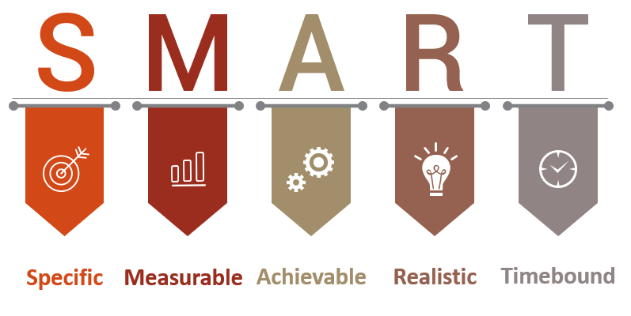
The SMART goals framework is key to developing strategies that are both visionary and practical, turning campaign plans from intentions into a set of achievable milestones with clear timelines and responsibilities.
Specific: Goals should be clear and well defined to effectively direct focus and efforts. A specific goal articulates what needs to be accomplished, who should be involved, where it will take place, and why it is important.
Measurable: A goal must have criteria for measuring progress and success. This makes it possible to track advancements, stay on schedule, and experience achievement that boosts morale and motivation.
Achievable: Setting goals that are realistic and attainable ensures that they are within the realm of possibility, given the available resources and time.
Relevant: The relevance of a goal ensures that it aligns with broader objectives and is meaningful to the cause and stakeholders involved.
Time-bound: Goals should have a clearly defined timeline, with a start and end date. This creates a sense of urgency and helps prioritize tasks.
SMART goals not only guide the planning and implementation of campaigns but also provide a framework for evaluation. By setting clear, measurable targets, you can assess effectiveness, make informed adjustments, and demonstrate impact.

Understanding Your Audience (PPT slide 19) 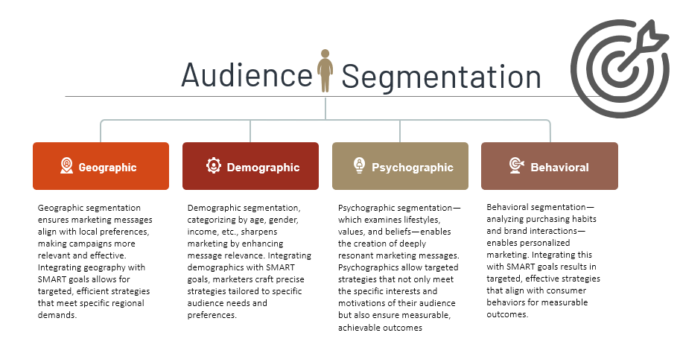
Understanding the layers of audience segmentation is vital to creating targeted, efficient media campaigns. Segmentation offer insights into audience preferences and behaviors, allowing for the development of localized marketing messages and campaigns. Integrating these segmentation layers with SMART goals can transform broad strategies into focused actions that precisely address the unique needs and desires of different audiences.
Geographic segmentation divides the market based on location, such as region, city, or neighborhood, ensuring that marketing messages and products align with local conditions.
Demographic segmentation involves categorizing the audience based on factors such as age, gender, income, education, and occupation. This helps tailor messages that resonate with specific life stages and social circumstances, vital for addressing different health topics.
Psychographic segmentation goes deeper into understanding the audience’s lifestyle, values, interests, and beliefs. Understanding your audience’s psychographic identities enables the creation of content that aligns with their inner motivations, which is especially significant in behavioral health, where personal values strongly influence decisions.
Behavioral segmentation focuses on the audience’s purchasing behaviors, usage rates, brand interactions, and loyalty. It allows for the creation of localized marketing strategies that cater to individual consumer behaviors.

An effective campaign thrives as a two-way conversation. Actively listening to community feedback sheds light on the effectiveness of our messaging, the suitability of our communication channels, and potential gaps in our audience understanding. This feedback allows us to adjust and improve our campaign to stay relevant, respectful, and impactful, thereby fostering a genuine connection with our audience.
Engaging Through Appropriate Channels (PPT slide 25)
Choosing the right channels to meet our audience where they are at is as vital as the message itself. This could mean tapping into local events, utilizing tribal radio stations, engaging on social media platforms, and partnering with schools and community groups. By aligning our channels with our audience’s preferences and cultural norms, we greatly enhance the chances of our message being embraced and acted on.
Cultivating Empathy in Messaging (PPT slide 26)
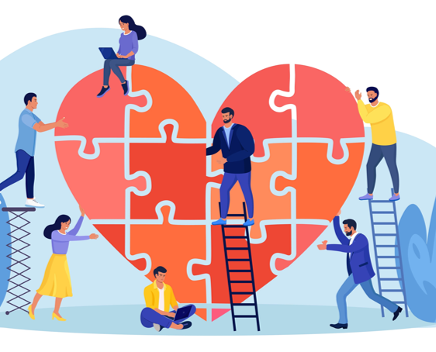
Empathy in messaging is the cornerstone of effective campaigns. It involves deeply understanding and mirroring the emotions, thoughts, and experiences of our audience, elevating standard messages into something profoundly resonant. When we infuse our messages with empathy, we’re not just acknowledging our audience’s challenges and aspirations; we’re building a connection that transcends simple awareness, fostering real engagement and prompting action. This approach not only amplifies the impact of our campaigns but also cements trust, making our messages stick with our audience in a meaningful way.
Closing of Day One
Tom Volk and Laurie Barger Sutter thanked participants for their attendance and closed day one.
Day Two
Welcome Back and Networking
Participants were welcomed back and given time to network with other prevention professionals around the room.
Regional Event Planning
Grantees then worked in small groups to brainstorm ideas for their regional events. Ideas were reported to the larger group and recorded for further discussion during subsequent quarterly consultations with Growth Partners.
Media 101, Continued
Storytelling in Marketing (PPT slide 29)
Randy Moser continued his presentation, picking up with the importance of narrative in marketing. By embedding our messages within stories that echo the audience’s own experiences and values, we can create campaigns that are deeply impactful. This approach does more than captivate the audience; it also makes complex messages approachable and engaging.
Incorporating storytelling into marketing can vary widely, from leveraging customer testimonials and case studies to creating animated videos or interactive experiences. The essence lies in ensuring these stories are in harmony with the campaign goals while genuinely mirroring the audience’s realities, thus authentically enhancing the campaign’s resonance and effectiveness.
Evaluating Campaign Effectiveness (PPT slide 33)
Evaluating a marketing campaign’s effectiveness goes beyond its reach, focusing on its impact on audience attitudes, knowledge, and behaviors. This involves both quantitative and qualitative metrics, from analytics to community feedback.
Quantitative methods like surveys, focus groups, and digital analytics reveal the campaign’s performance, guiding data-driven improvements for future efforts. This continual evaluation process refines current campaigns and shapes more effective future strategies, ensuring they meet and serve our audience’s needs effectively.
The qualitative impact—including shifts in audience attitudes, heightened awareness, and individual stories of change—holds significant value. Gathering qualitative data through surveys and interviews provides a deeper understanding of the campaign’s effect on perceptions and behaviors. These narratives and testimonials are strong indicators of a campaign’s success, offering insights that can guide future strategies by pinpointing areas of strong impact or identifying opportunities for enhancement.
Adapting to Feedback and Trends (PPT slide 35)
Responding to audience feedback and trends promptly, adapting messages, exploring new channels, and modifying tactics to align with the audience’s changing needs are all key. Moreover, vigilance toward industry trends and technological innovations opens doors to novel campaign innovations, ensuring our methods stay current and compelling. Marketing landscapes and audience preferences are in constant flux, necessitating an ongoing commitment to learning and innovation. Being open to new strategies, technologies, and platforms is critical. Fostering a culture of curiosity is essential—continual education helps us stay informed about the latest trends and practices.
Introduction to Personas (PPT slide 38)
Marketing personas are fictional characters that epitomize various segments of a target demographic, capturing the essence of large audience groups. They are integral to developing campaign strategies and messages tailored to the unique needs, beliefs, and behaviors of each segment, thus boosting the relevance and efficacy of marketing initiatives. Persona profiles are created by collecting data and include details like name, age, occupation, interests, challenges, goals, and communication preferences. They lend realism and relatability that help you craft targeted messaging and strategic plans. This approach ensures campaigns resonate personally with the audience.
For a persona-driven campaign to be effective, it’s vital that the creative direction, messaging, and channel choices accurately reflect the personas’ realities and experiences. Messages should tackle their specific challenges and aspirations, using stories and scenarios that reflect their life experiences to enhance connection and authenticity. Selecting appropriate communication channels is crucial for engaging personas where they are most engaged, thus optimizing campaign reach.
Moreover, personas guide decision making in campaign planning, influencing everything from messaging and branding to content creation. Their preferences and behavior shape engagement tactics for maximum interaction. As personas are dynamic, they should be continually updated with campaign data and feedback to maintain their relevance and effectiveness. Utilizing feedback mechanisms like surveys and analytics aids in refining personas, keeping campaigns in tune with audience expectations and increasing message authenticity and impact.
Messaging Strategies and Channels
Digital marketing opens a world of possibilities for reaching and engaging audiences through the platforms that have become a part of their daily lives. This means an opportunity to spread information and offer services in ways that are both accessible and captivating, bridging gaps left by traditional media.
The Goldilocks Problem: There’s a delicate balance to strike in segmentation. Too broad, and your message may lack relevance. Too narrow, and the audience size may become insignificant, undermining the campaign’s potential reach. Finding the “just right” audience size ensures messages are relevant without sacrificing reach.
Tailoring and Targeting Messages (PPT slide 48)
Customizing messages to specific populations greatly amplifies the relevance and engagement of a campaign. It’s essential to consider demographic factors, interests, and geographical nuances to craft communications that resonate deeply with the intended audience, thereby increasing the campaign’s effectiveness.
Gathering data is a critical step in tailoring messages. Surveys, community forums, and social media analytics are valuable tools for gaining insights into the local community’s preferences and needs.
Navigating Stigma in Behavioral Health: Stigma presents a considerable challenge in behavioral health. Crafting messages that challenge stigmas requires a deep understanding of local attitudes and a careful choice of language and imagery. It’s about striking a balance between challenging misconceptions and respecting existing beliefs.
Messages should incorporate educational elements that debunk myths and present clear, factual information about behavioral health, emphasizing common human experiences to foster empathy and understanding.
Embracing Diversity: Diverse marketing not only fulfills a moral obligation but also offers a strategic benefit. It ensures that campaigns reflect the myriad experiences within a community and connect with a wider audience.
Inclusive Messaging: This approach goes beyond imagery. It entails creating content and strategies that are accessible and relevant to people across the spectrum of age, culture, gender, and abilities.
Seeking Diverse Perspectives: Involving a range of perspectives in the campaign’s development can spur creativity and ensure that communications are respectful and inclusive.
Localized Campaign Elements
- Embrace Local Diversity: Understand and reflect the community’s multifaceted nature in your messaging.
- Cultural Relevance: Align your messaging with local traditions and languages to ensure authenticity.
- Community Connection: Engage with local communities to build trust and foster loyalty.
- Global Impact: By accurately mirroring local diversity, campaigns can resonate more broadly and enhance the brand’s global standing.
Crafting Messages That Empower (PPT slide 51)
Empowering the community through messaging involves striking a delicate balance: You must provide crucial information while also sparking hope and resilience. Empowering messages encourage the community to take positive action. Here’s how to approach it:
- Whenever possible, substitute stock photos with authentic photos to foster trust and connection.
- Focus on solutions rather than just presenting problems. Positive framing is key to inspiring action. To implement this:
  - Highlight the effectiveness of collective action for systemic change.
  - Present solutions as achievable to foster belief in positive change.
  - Shift toward optimistic messaging that drives people to engage with and address social problems.
  - Celebrate even small victories to build momentum and encourage ongoing engagement.
  - Provide clear calls to action to guide the community towards the next steps they can take.
- Sticky Language: Memorable and effective messages that stick with the audience do more than convey information; they embed themselves in the collective consciousness and prompt action. For example:
  - Nike’s “Just Do It” captures the spirit of determination and motivates action.
  - Apple’s “Think Different” celebrates creativity and individuality.
To create messages that stay with the audience, consider the following:
  - Use memorable phrases and impactful gestures to capture and keep attention.
  - Adjust language and presentation style based on the audience’s cultural and demographic background.
- Being sensitive to cultural and demographic nuances ensures that your message is respectful and well received. This includes:
  - Tailoring language and gestures to the audience’s cultural context.
  - Being aware of nonverbal communication styles and preferences across cultures.
By crafting messages that resonate on a deeper level, we can not only inform but also inspire and empower our audiences, leading to a more engaged, informed, and proactive community.

Getting Candid: Framing the Conversation Around Youth Substance Use Prevention
Pam Pietruszewski and Amanda Stark from the National Council for Mental Wellbeing presented on the Getting Candid project (see Appendix C). The presentation outlined the National Council’s efforts to assess and address substance use risks among youth. The initiative leverages national assessments, focus groups, and a Youth Ambassador Program to develop targeted messaging and resources designed to empower providers and other adults with the ability to communicate with young people in a direct and impactful manner.
Key Components:
- Purpose and Approach: The project aimed to assess the pandemic’s impact on substance use risks among youth using national online assessments, focus groups, and expert advisors to create a toolkit for providers and prevention professionals.
- Advisory and Youth Ambassadors: A diverse group of organizations and individuals, including Youth Ambassadors, contributed to the project, ensuring a wide range of perspectives and experiences were considered.
- Learning Objectives: These objectives emphasized reviewing youth assessment findings, applying communication strategies for effective messaging, engaging youth in content and design, and discussing implementation of the Getting Candid message guide, toolkit, and other resources.
Key Findings: (PPT slides 7–11)
- Youth vs. Provider Perceptions: The project identified disparities in perceptions between youth and providers regarding substance use risks and communication effectiveness.
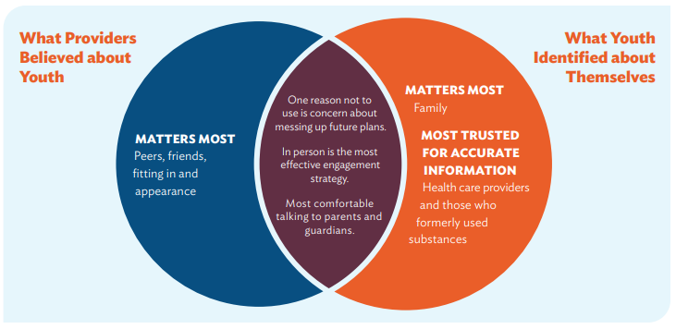
- Trust vs. Comfort: While youth said they trust providers the most for information about substance use, they are most comfortable speaking with parents/caregivers and friends/peers about these topics.
- Resiliency and Optimism: These factors highlighted youth’s resilience and optimism despite challenges, underscoring the importance of leveraging these qualities in prevention efforts.
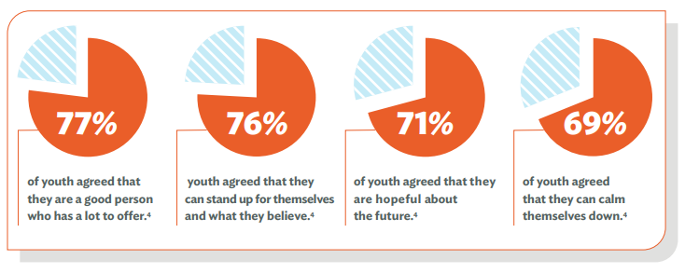
- Reasons Not To Use: Below were the top reasons youth choose not to engage in substance use, including health concerns and aspirations for the future.
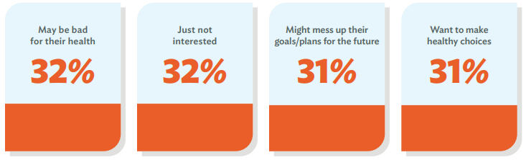
- Rural Youth: (PPT slide 12) Special attention was given to the unique challenges and perspectives of youth in rural areas, including easier access to substances and higher stress levels.
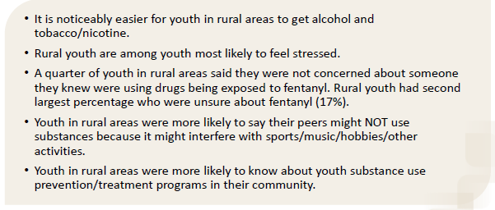
- Engaging with Youth: (PPT slide 13) Youth-serving providers are tasked with creating a safe environment for open discussions about substance use and its impact on health, education, finances, and relationships. Providers are encouraged to use regular touchpoints with youth to emphasize prevention messages and support healthy peer relationships. Identifying potential risk and protective factors was also highlighted as crucial in mitigating risks and fostering a supportive environment for youth.
Communication and Engagement Strategies: (PPT slide 16)
- Communication Pathway: Pam outlined a framework for crafting impactful messages, emphasizing the importance of framing communication, making a compelling case, and suggesting actionable steps.
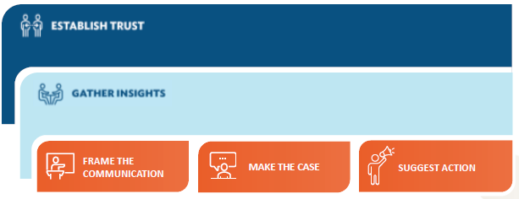
Youth Ambassador Program: (PPT slides 25–33) This section described the program’s structure and activities, including social media campaigns and participation in panels, to amplify youth voices and perspectives as well as compensation and recruitment practices.
Resources and Implementation:
- Toolkit and Resources: Introduced a comprehensive toolkit and resources, including Substance Fact Sheets and a Cannabis Resource Center, to support substance use prevention efforts.
- Implementation Discussion: Encouraged participants to assess their current engagement with youth and to identify areas for growth and development in their prevention initiatives.

Closing
Tom Volk and Laurie Barger Sutter closed the meeting by thanking attendees for their participation and having them complete the meeting evaluation.
Appendixes
Appendix A: Meeting Agenda
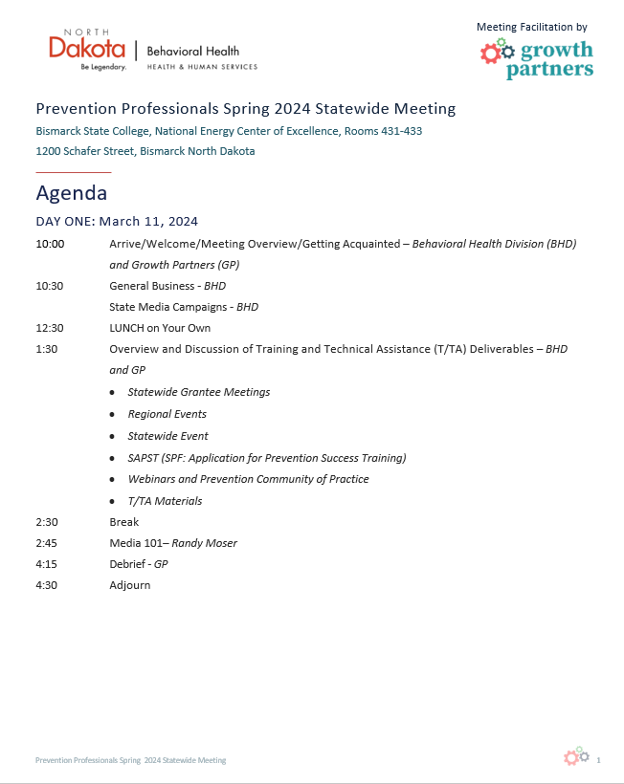
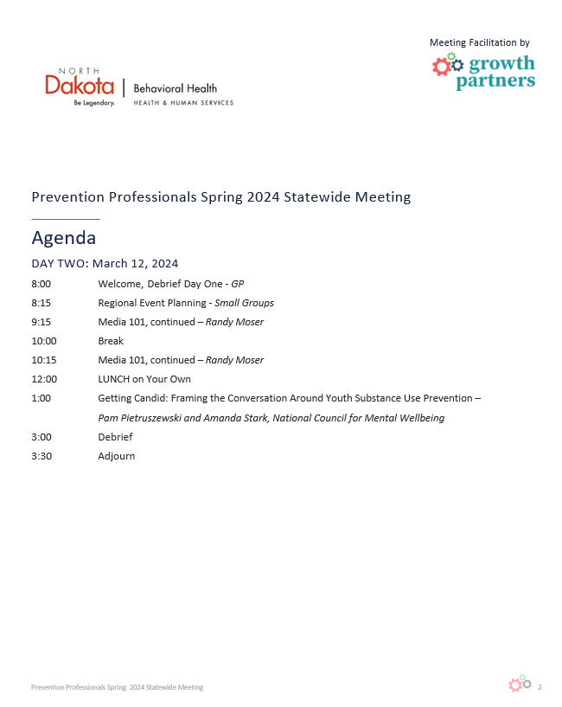
Appendix B: T/TA Deliverables Handout
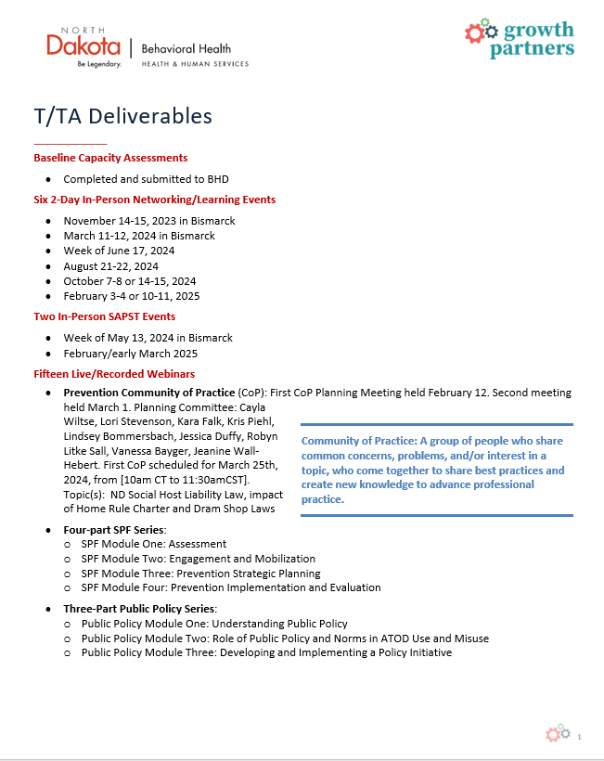
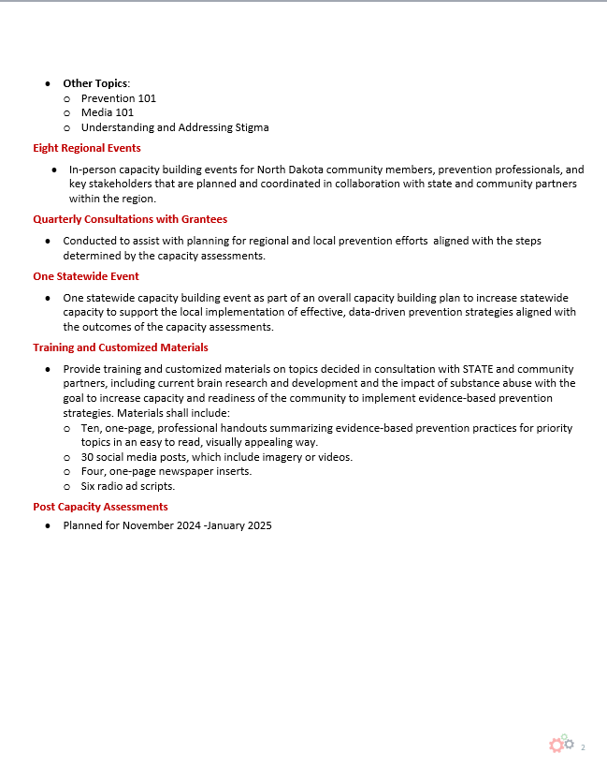

Appendix C: Getting Candid: Framing the Conversation Around Youth Substance Use Prevention
